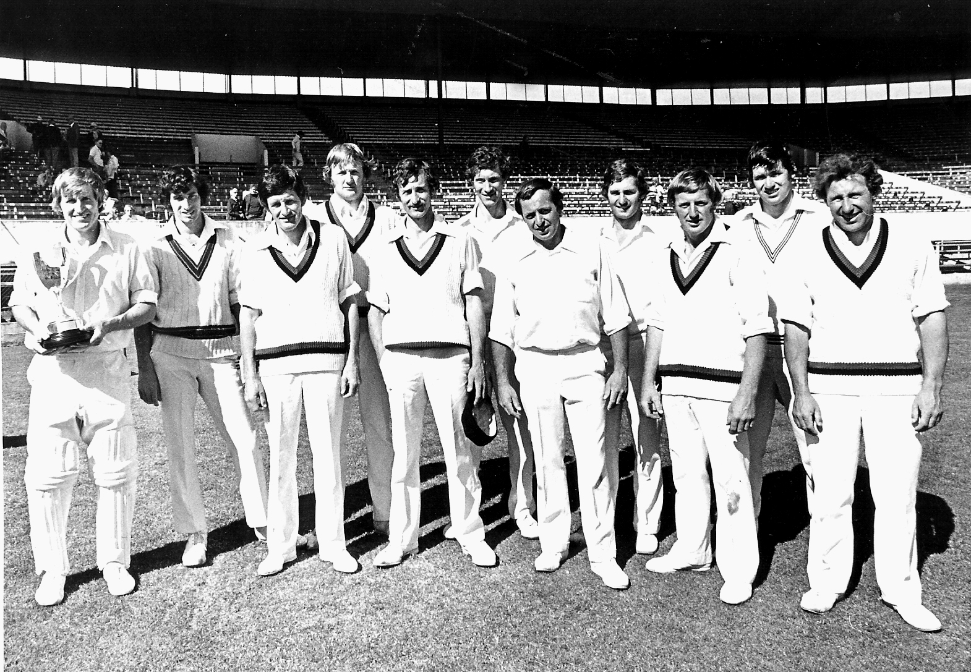  **Canterbury Representative Team 1977/78 Winners Gillette Cup**

**From left:** ML Ryan captain, RJ Hadlee, BE Congdon, RH King, DR Hadlee, SL Boock, AE Collins, PE McEwan,

DW Stead, NM Parker, PG Coman